**AFRINREN Meeting 7 with Hussein Suleman**

**Project**

* Project plan decided. Hussein will email to us (hopefully).
  + Iteration 1 (Start next week - 3 weeks long): Requirements Gathering
    - Design (Paper Prototype?)
    - Implement
    - Evaluate
  + Iteration 2: Consult with users
  + Iteration 3

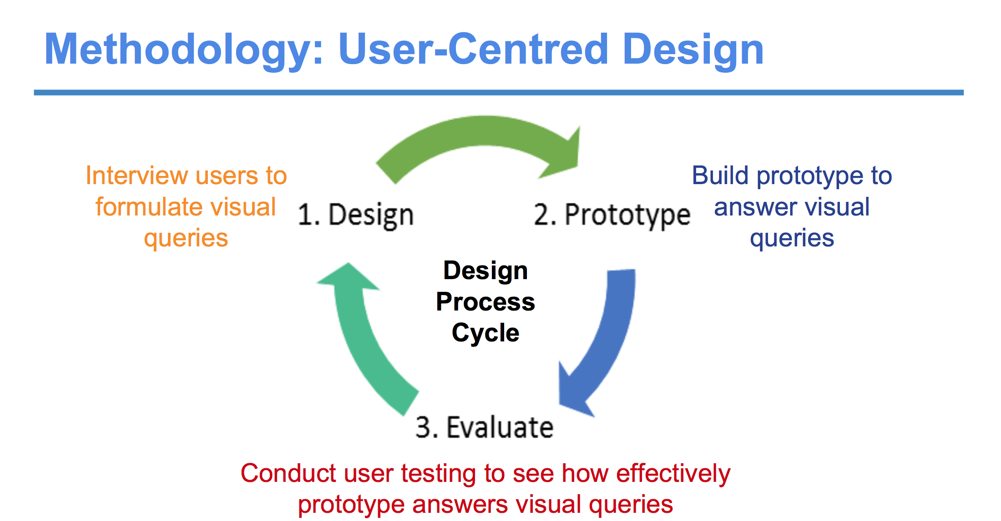

Design

Experimentation

Evaluation

**Project Report**

* Hussein estimates report should take just over a week to write report
* 10 pg ACM format

**Points of Action:**

* Work on background chapter (should be page to page and a half)
* Carry on working on each of our sections independently
* Next week decide on method for user requirements gathering
  + Survey? Obtain mailing list of people from African Network Community (Ask Josiah?)
  + Interview?
  + Focus Group?
* Start formulating questions for survey and/or interviews
* Run past Hussein and Josiah

**Due Dates:**

* 7 Aug: Lit Review Section of Report Due
* Dedicated project block starts on 21 August
* 25 September: Design Section Due - Statement of Design Process and Final Design
* 16 October: Final Draft of Report
* 26 October: Final Project Submission (Code + Report)

**Next Meetings (Hussein away for 3 weeks):**

* 30 July Thursday 11am-12pm
* 6 Aug Thursday 11am-12pm